Team Evaluation:

* Richard Huang
  + Created the PCA Algorithms function so that Brendan and Eden can work on their part.
* Brendan Rizzo
  + Using what Richard created, came up with a method to calculate the reconstruction error for each d value.
* **Eden Seo**
  + Using Richard’s function, created a function to reconstruct an image for each d value
* Jiashang Cao
  + Same as last time. Where is this person? I have no clue.

1. Implement PCA
   1. When d = 10
      1. 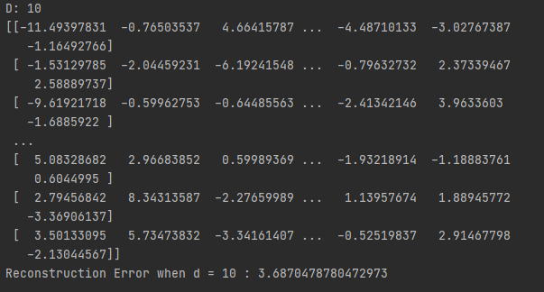
      2. 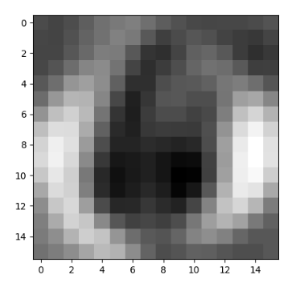
   2. When d = 50
      1. 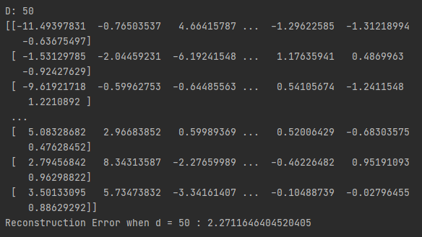
      2. 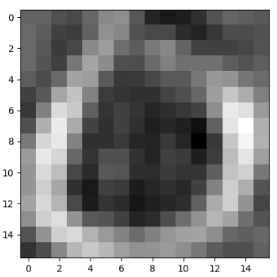
   3. When d = 100
      1. 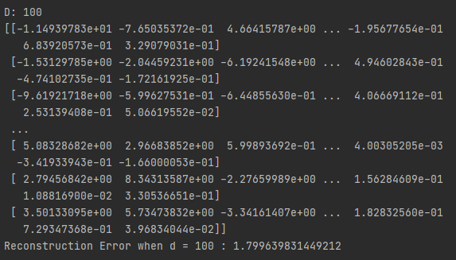
      2. 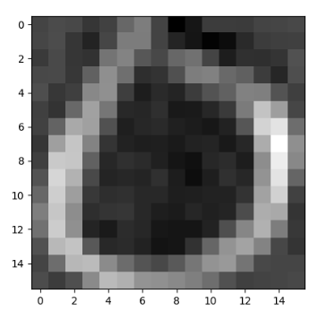
   4. When d = 200
      1. 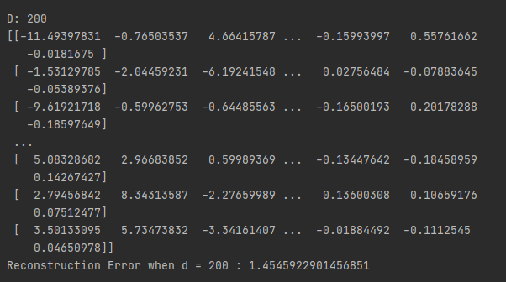
      2. 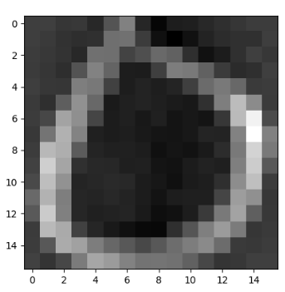

Side-by-side Comparison

 d = 10 d = 50 d = 100 d = 200